**ASSISTED PRACTICE (RANDOM AND RANDOM ORDER CONTROLLERS)**

Random Controller:

Step1: Record some steps using blazemeter of Heroku app

Step2: Then, Open this recorded file in Jmeter

Step3: Right click on Thread Group -> Add -> Logic controller -> Add three Simpler controllers

Step4: Make separate simple controllers for all of the recorded steps

Step5: Right click on Thread Group -> Add -> Logic controllers -> Random controller (Place all the clicking steps of heroku app that we perform inside this controller) and Two simple controllers (one for login step and one for logout step)

Step6: In Thread Group -> Give the Number of users as “3”

Step7: Right click on Thread Group -> Add -> Listener -> View Results tree

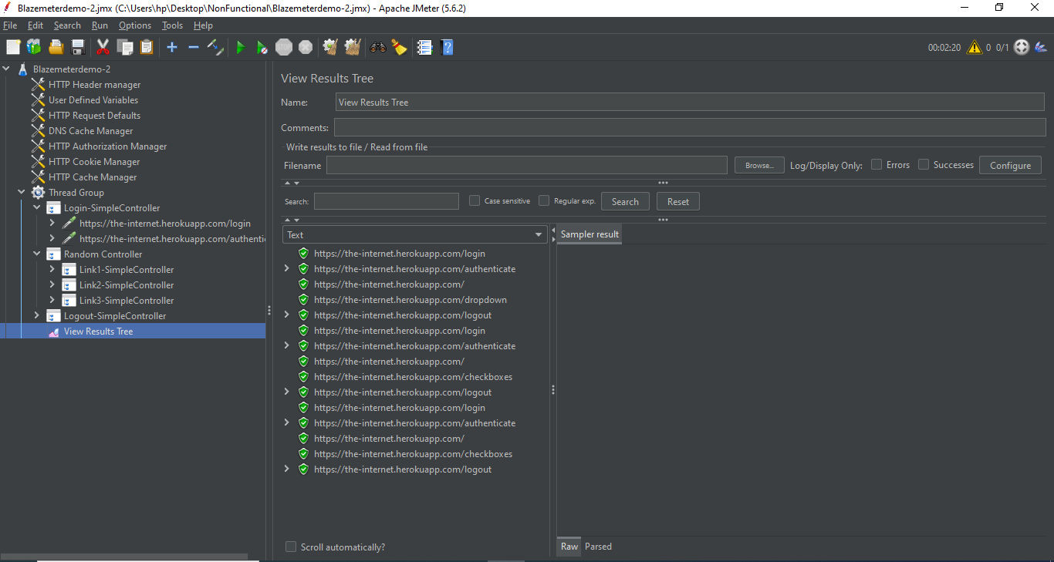

Random order Controller:

Step1: Record some steps using blazemeter of Heroku app

Step2: Then, Open this recorded file in Jmeter

Step3: Right click on Thread Group -> Add -> Logic controller -> Add three Simpler controllers

Step4: Make separate simple controllers for all of the recorded steps

Step5: Right click on Thread Group -> Add -> Logic controllers -> Random order controller (Place all the clicking steps of heroku app that we perform inside this controller) and Two simple controllers (one for login step and one for logout step)

Step6: In Thread Group -> Give the Number of users as “1”

Step7: Right click on Thread Group -> Add -> Listener -> View Results tree

